Lab 06 – Worksheet

Name: Mohammad Jazib Javed / Ahmad Tariq | ID: 11972/ 10770 | Section: T4

Note: Assumptions and logics should be explained separately in tasks after the task results.

Task 1
Block Diagrams
1 bit ALU block diagram:

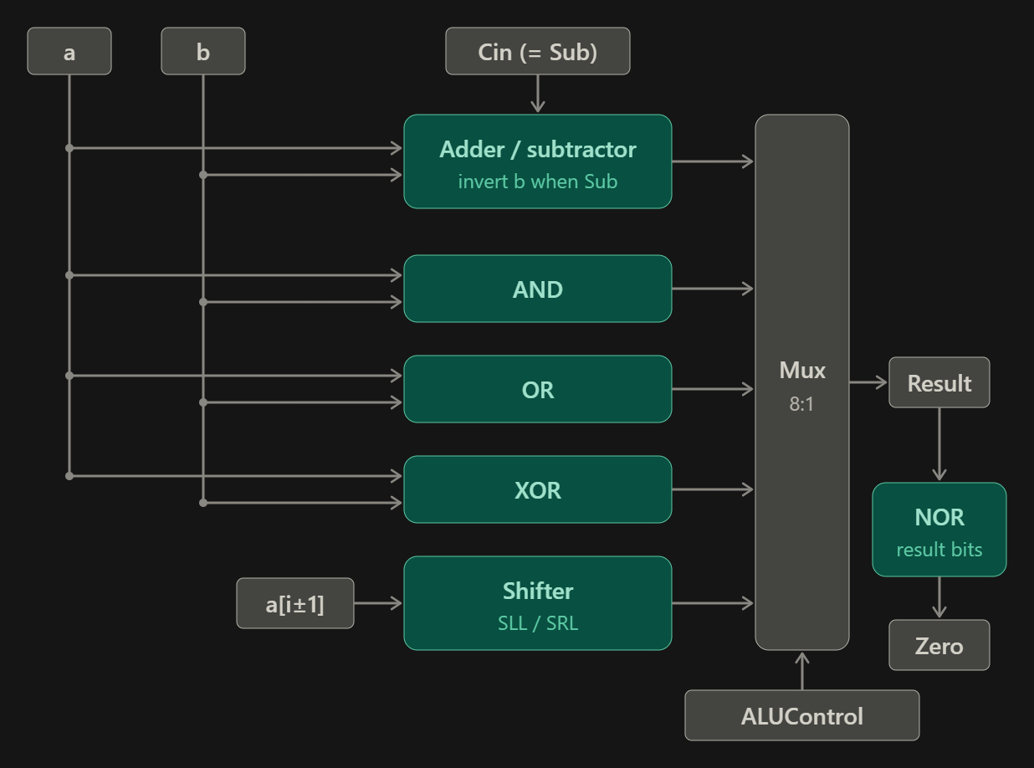

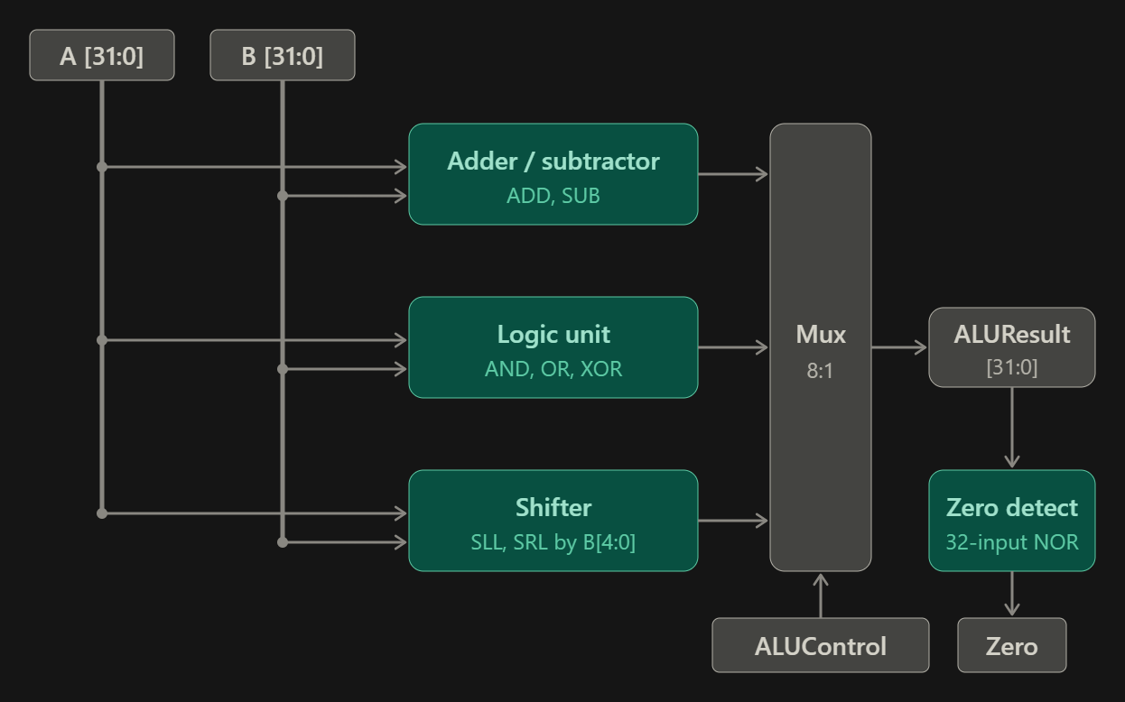
32 bit ALU block diagram:

Comments

ALUControl | Operation | Result
0000 | ADD | A + B
0001 | SUB | A − B
0010 | AND | A & B
0011 | OR | A | B
0100 | XOR | A ^ B
0101 | SLL | A << B[4:0]
0110 | SRL | A >> B[4:0]
0111 | BEQ | A − B, with Zero = 1 when A == B

Task 2

Modules + Testbench:
MODULE:

`timescale 1ns / 1ps
//////////////////////////////////////////////////////////////////////////////////
// Company:
// Engineer:
//
// Create Date: 09/30/2026 02:13:27 PM
// Design Name:
// Module Name: ALU
// Project Name:
// Target Devices:
// Tool Versions:
// Description:
//
// Dependencies:
//
// Revision:
// Revision 0.01 - File Created
// Additional Comments:
//
//////////////////////////////////////////////////////////////////////////////////

module ALU(
input [31:0] A, // Operand A
input [31:0] B, // Operand B
input [3:0] ALUControl, // Selects which operation to perform
output reg [31:0] ALUResult, // Result of the ALU
output Zero // high when the result is 0
);

always @(*) begin //Used for combinational logic (creates its own sensitivity list)
case (ALUControl)
4'b0000: ALUResult = A + B; // ADD
4'b0001: ALUResult = A - B; // SUB
4'b0010: ALUResult = A & B; // AND
4'b0011: ALUResult = A | B; // OR
4'b0100: ALUResult = A ^ B; // XOR
4'b0101: ALUResult = A << B[4:0]; // SLL: shift A left by B[4:0] bits
4'b0110: ALUResult = A >> B[4:0]; // SRL: shift A right by B[4:0] bits
4'b0111: ALUResult = A - B; // BEQ: subtract, Zero = 1 if A == B
default: ALUResult = 32'b0; // unused codes output 0
endcase
end
assign Zero = (ALUResult == 32'b0); // Zero flag: high when every bit of the result is 0

endmodule

TestBench:

`timescale 1ns / 1ps
//////////////////////////////////////////////////////////////////////////////////
// Company:
// Engineer:
//
// Create Date: 09/30/2026 02:19:14 PM
// Design Name:
// Module Name: ALU_tb
// Project Name:
// Target Devices:
// Tool Versions:
// Description:
//
// Dependencies:
//
// Revision:
// Revision 0.01 - File Created
// Additional Comments:
//
//////////////////////////////////////////////////////////////////////////////////

module ALU_tb();
reg [31:0] A, B;
reg [3:0] ALUControl;
wire [31:0] ALUResult;
wire Zero;

ALU dut (.A(A), .B(B), .ALUControl(ALUControl),
.ALUResult(ALUResult), .Zero(Zero));

initial begin
A = 32'hAAAAAAAA; B = 32'h55555555;

ALUControl = 4'b0000; #10; // ADD = FFFFFFFF
ALUControl = 4'b0001; #10; // SUB = 55555555
ALUControl = 4'b0010; #10; // AND = 00000000, Zero = 1
ALUControl = 4'b0011; #10; // OR = FFFFFFFF
ALUControl = 4'b0100; #10; // XOR = FFFFFFFF

A = 32'h00000001; B = 32'h00000004;
ALUControl = 4'b0101; #10; // SLL = 00000010

A = 32'h80000000; B = 32'h0000001F;
ALUControl = 4'b0110; #10; // SRL = 00000001

A = 32'h12345678; B = 32'h12345678;
ALUControl = 4'b0111; #10; // BEQ equal = 00000000, Zero = 1

B = 32'h12345679;
ALUControl = 4'b0111; #10; // BEQ not equal = FFFFFFFF, Zero = 0

$finish;
end

endmodule

Results:
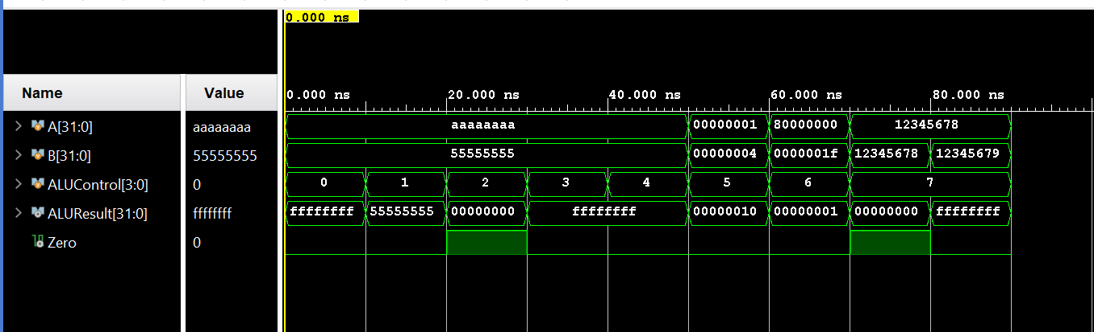

Task 3

RTL Schematics
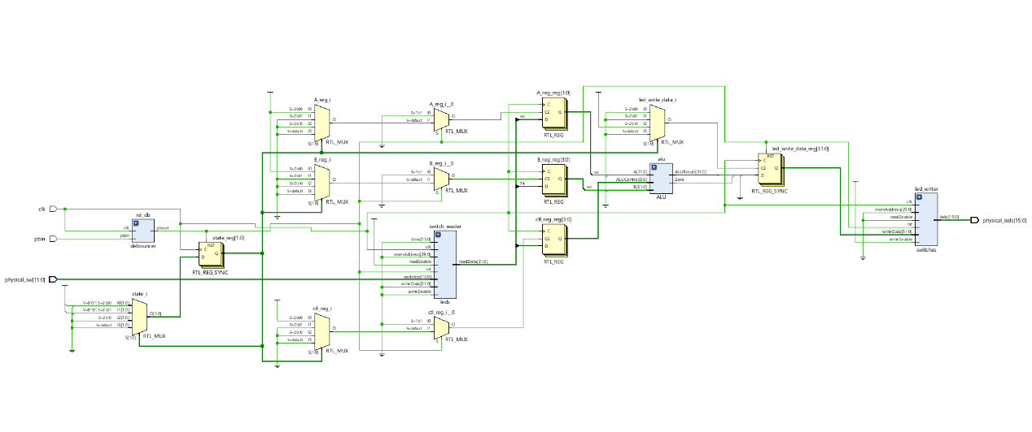

`timescale 1ns / 1ps

//////////////////////////////////////////////////////////////////////////////////

// Company:

// Engineer: Muddassir Ali

// Module Name: top_fsm_system

// Project Name: Counter

// Target Devices: Baasys 3

//

//////////////////////////////////////////////////////////////////////////////////

module top_fsm_system (

input wire clk,

input wire pbin,

input wire [15:0] physical_sw,

output wire [15:0] physical_leds

);

// DEBOUNCER (Cleans up the physical reset button signal)

wire rst_clean;

wire [31:0] switch_data; // hold the value read from the switches

reg [31:0] led_write_data = 32'd0; // counter value here

wire slow_clk;

debouncer rst_db (

.clk(clk),

.pbin(pbin),

.pbout(rst_clean) //generated a clean signal

);

leds switch_reader (

.clk(clk), .rst(rst_clean),

.btns(16'd0), // Not used for this FSM

.writeData(32'd0), // We don't write to switches

.writeEnable(1'b0), // Disabled

.readEnable(1'b1), // Always ON so we can monitor switches

.memAddress(30'd0),

.switches(physical_sw), // Plug in the physical switches

.readData(switch_data) // output data

);

switches led_writer (

.clk(clk), .rst(rst_clean),

.writeData(led_write_data),

.writeEnable(1'b1), // Always ON so LEDs update instantly

.readEnable(1'b0), .memAddress(30'd0),

.readData(), // Ignored

.leds(physical_leds)

);

// clock_divider ticker (

// .clk_in(clk), // Feed it the 100MHz fast clock

// .rst(rst_clean), // Feed it the clean reset signal

// .clk_out(slow_clk) // It spits out the 1Hz slow clock!

// );

// YOUR FSM AND COUNTER LOGIC

// YOUR CODE HERE

// Registers that hold the inputs read by the FSM

reg [3:0] A_reg = 0; //stores operand A

reg [3:0] B_reg = 0; //stores operand B

reg [3:0] ctl_reg = 0; // stores the operation code

// ALU (4-bit inputs zero-extended to 32 bits)

wire [31:0] ALUResult; //32 bit result coming out of the ALU

wire Zero; //Goes to 1 when result is 0

ALU alu (

.A({28'd0, A_reg}), //taking 4 bit input for A so zero extend to 32 bits

.B({28'd0, B_reg}), //taking 4 bit input for B so zero extend to 32 bits

.ALUControl(ctl_reg),

.ALUResult(ALUResult),

.Zero(Zero)

);

// FSM: READ switches -> COMPUTE -> SHOW on LEDs -> repeat

localparam S_READ = 2'd0, //State 0 : Read the switches (Get A,B And ALUcontrol values)

S_COMPUTE = 2'd1, //State 1 : ALU performs operation

S_SHOW = 2'd2; //State 2 : Display ALU result on LEDs

reg [1:0] state = S_READ; // Register holding the current state (starts at State 0)

always @(posedge clk) begin

if (rst_clean) begin

state <= S_READ; //reset:go back to the first state

led_write_data <= 32'd0; // turns all leds off when reset

end

else begin

case (state)

S_READ: begin

A_reg <= switch_data[3:0]; //save A from switches

B_reg <= switch_data[7:4]; //save B from switches

ctl_reg <= switch_data[11:8]; //save operation code

state <= S_COMPUTE; //move to next state (compute)

end

S_COMPUTE: begin

state <= S_SHOW; // wait one cycle for the ALU (using nonblocking assignment)

end

S_SHOW: begin

// LED15 = Zero signal display

// LED14-LED0 = lower 15 bits of the result

led_write_data <= {16'd0, Zero, ALUResult[14:0]};

state <= S_READ; // goes back to read state

end

default: state <= S_READ; // to prevent a latch (any unknown state resets to read state)

endcase

end

end

endmodule

Design Timing Summary:

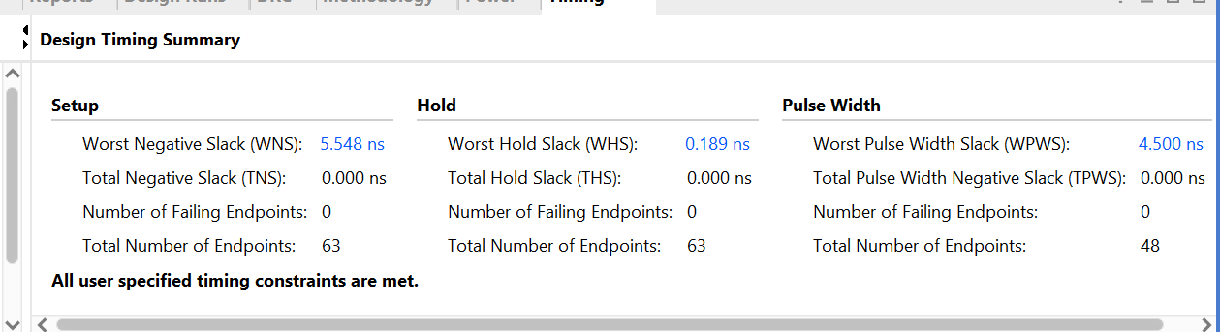

Power consumption:

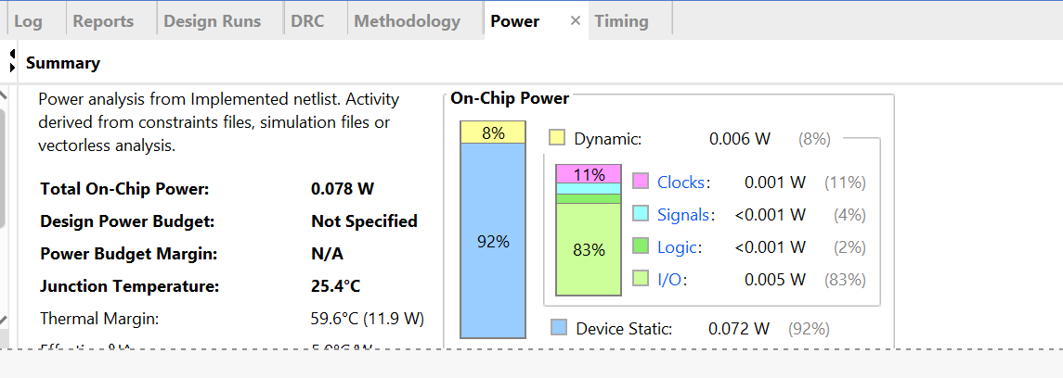

Results:

A= 4 , B = 2

ALU control = 0000 (ADD):

LED output = 6
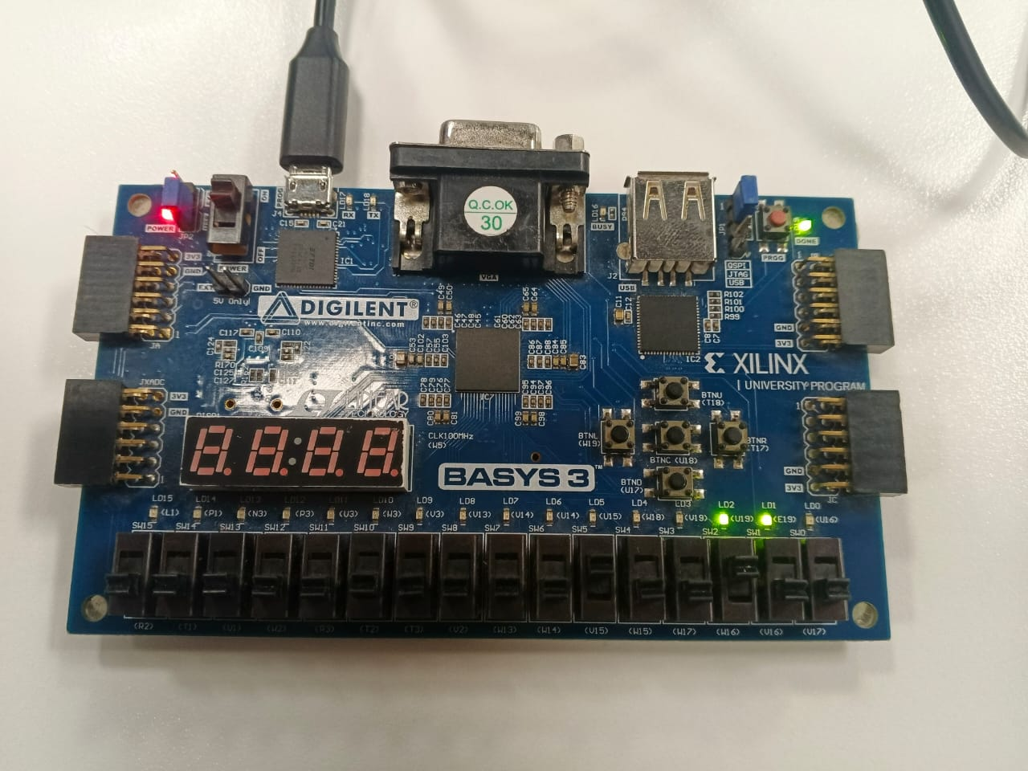

ALU control = 0001 (SUB):

LED output = 2
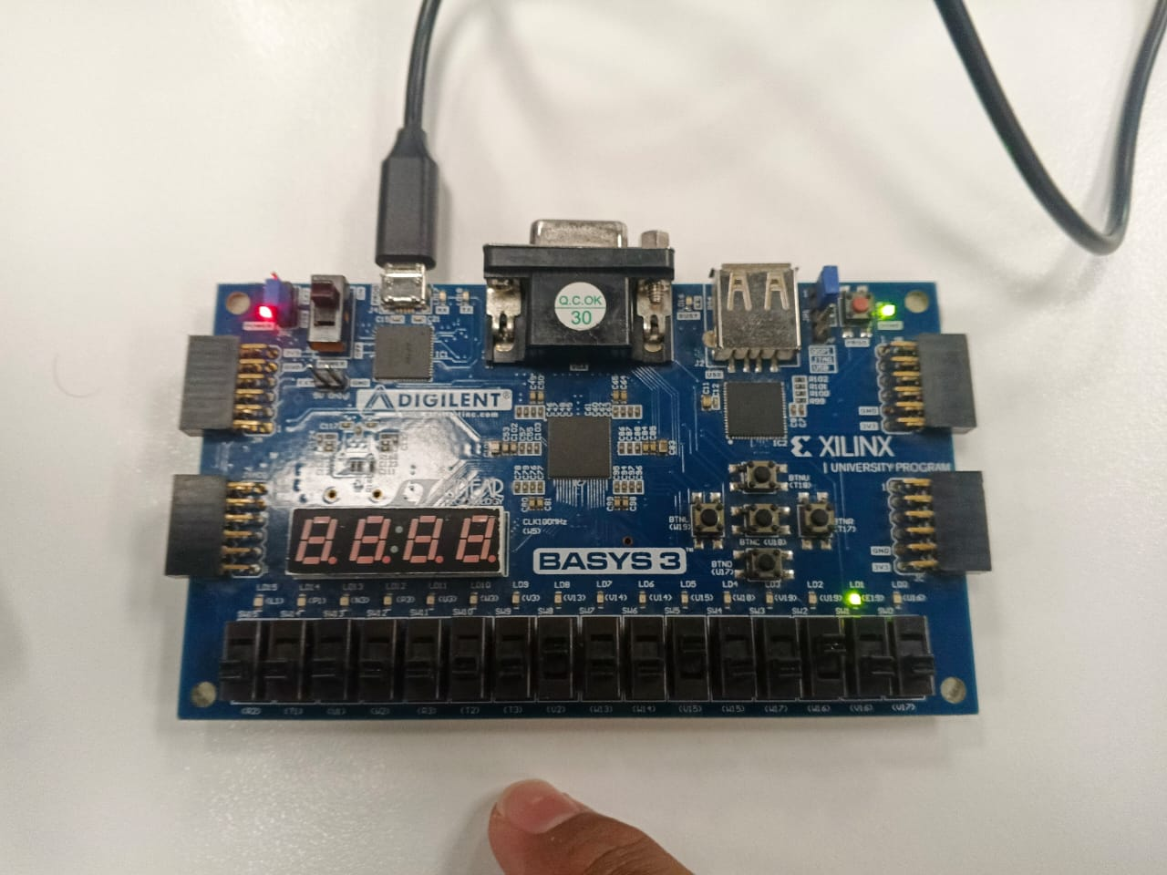

ALU control = 0010 (AND):

LED output = 0 (Zero signal high)

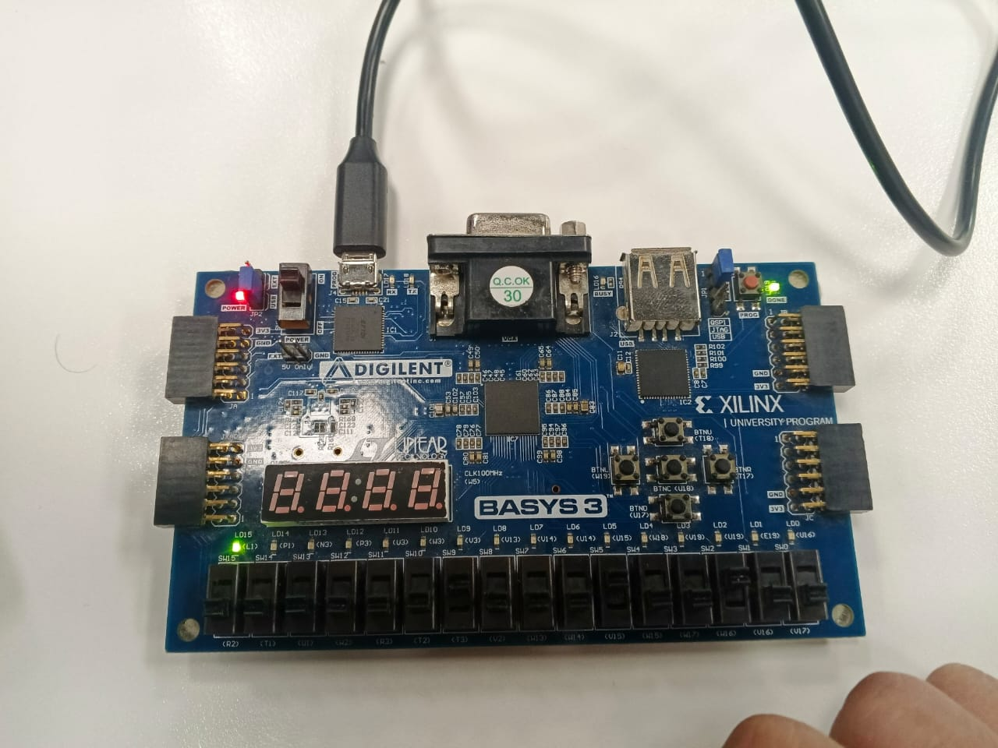

ALU control = 0011 (OR):

LED output = 6

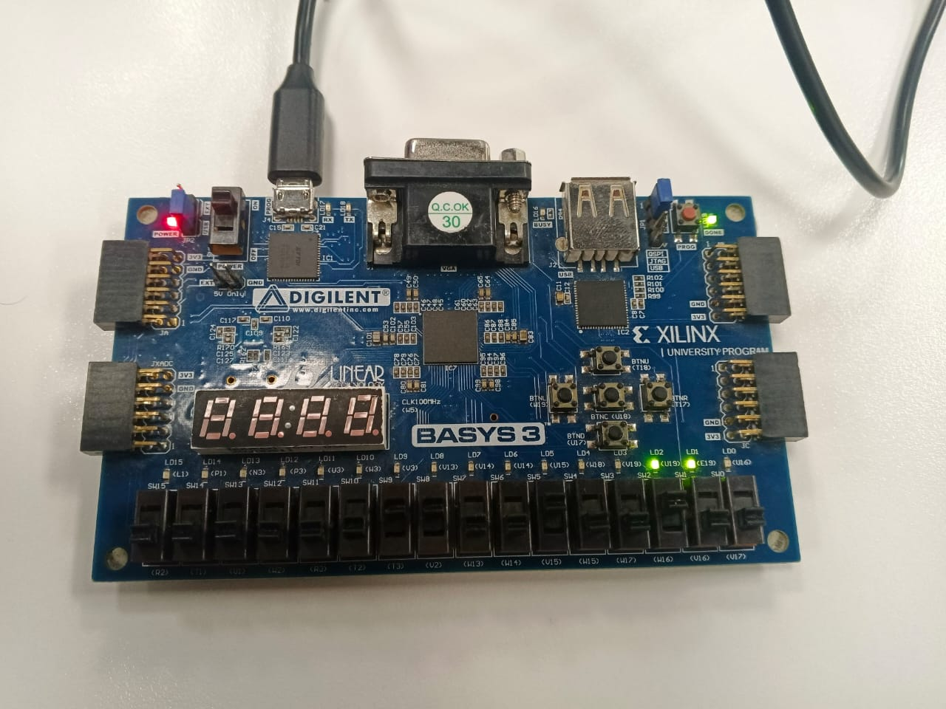

ALU control = 0100 (XOR):

LED output = 6

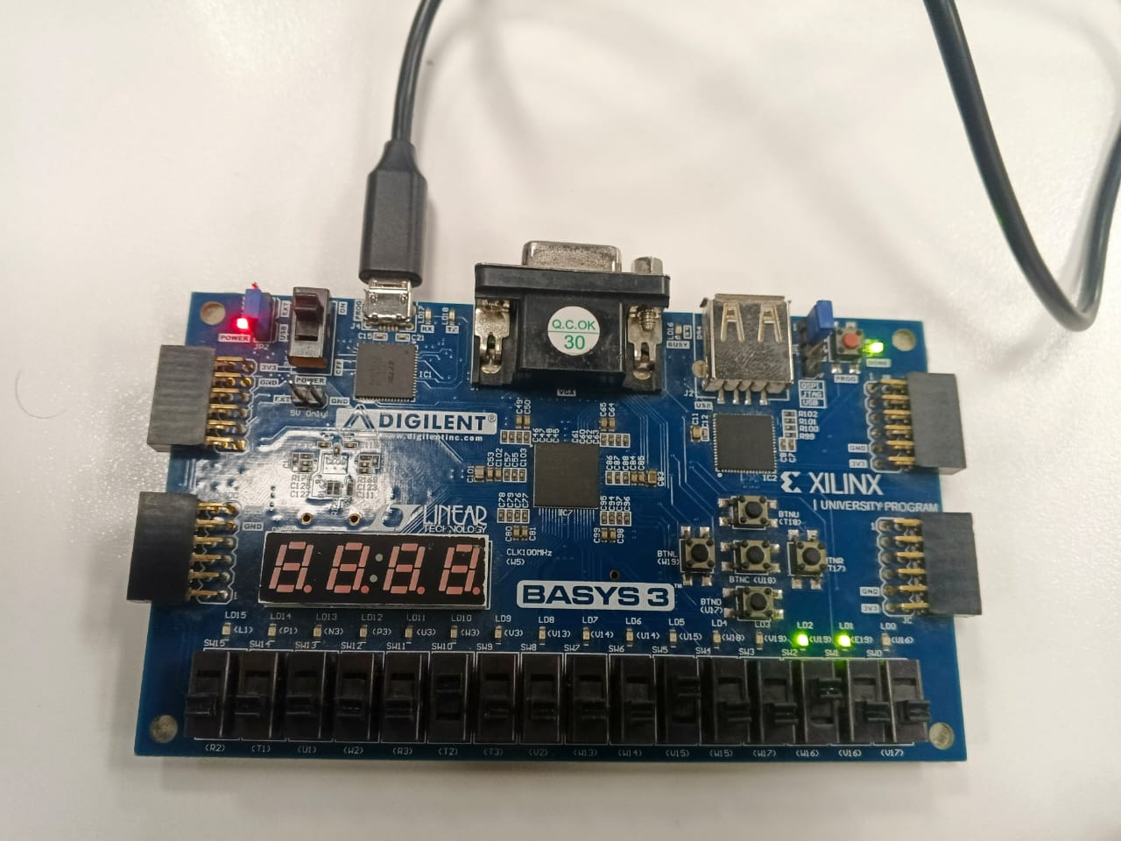

ALU control = 0101 (SLL):

LED output = 16

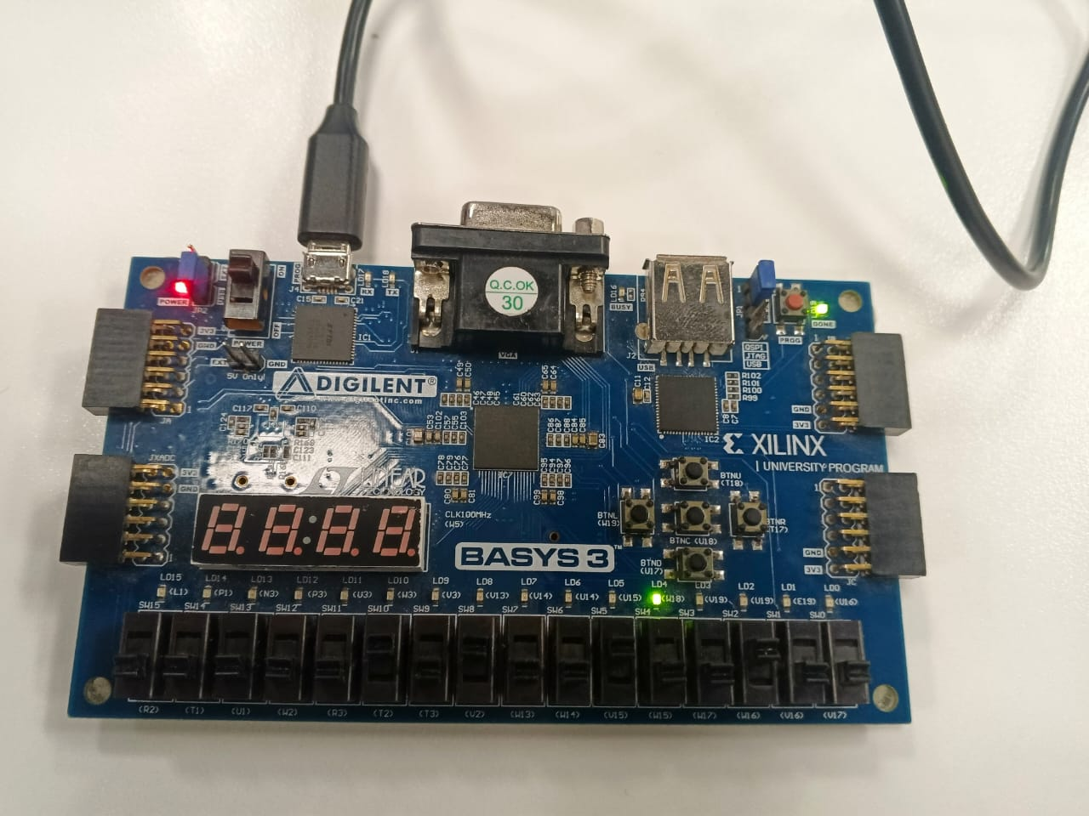

ALU control = 0110 (SRL):

LED output = 1

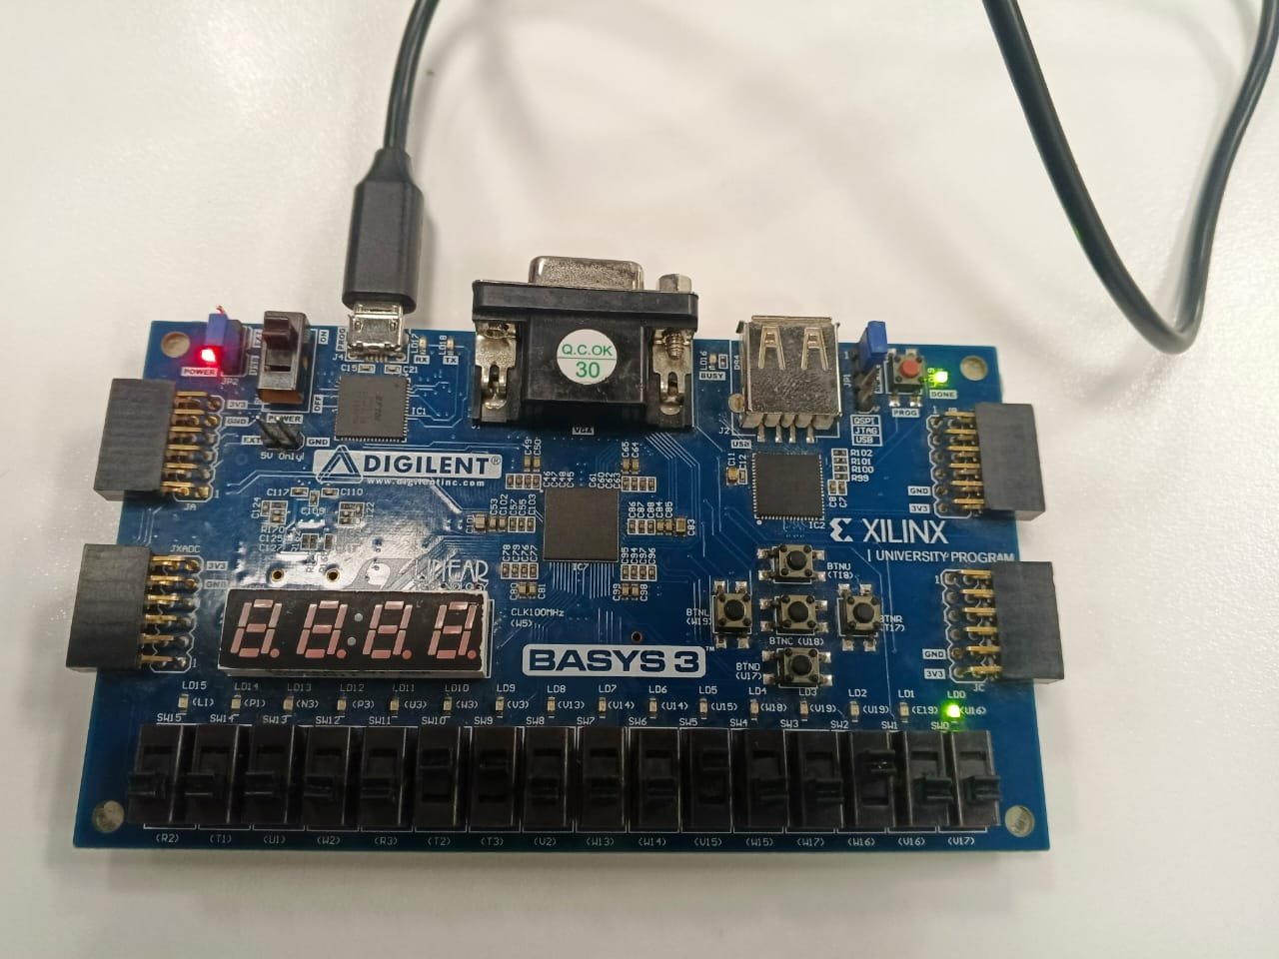

ALU control = 0111 (BEQ):

LED output = 2 (Zero signal low)

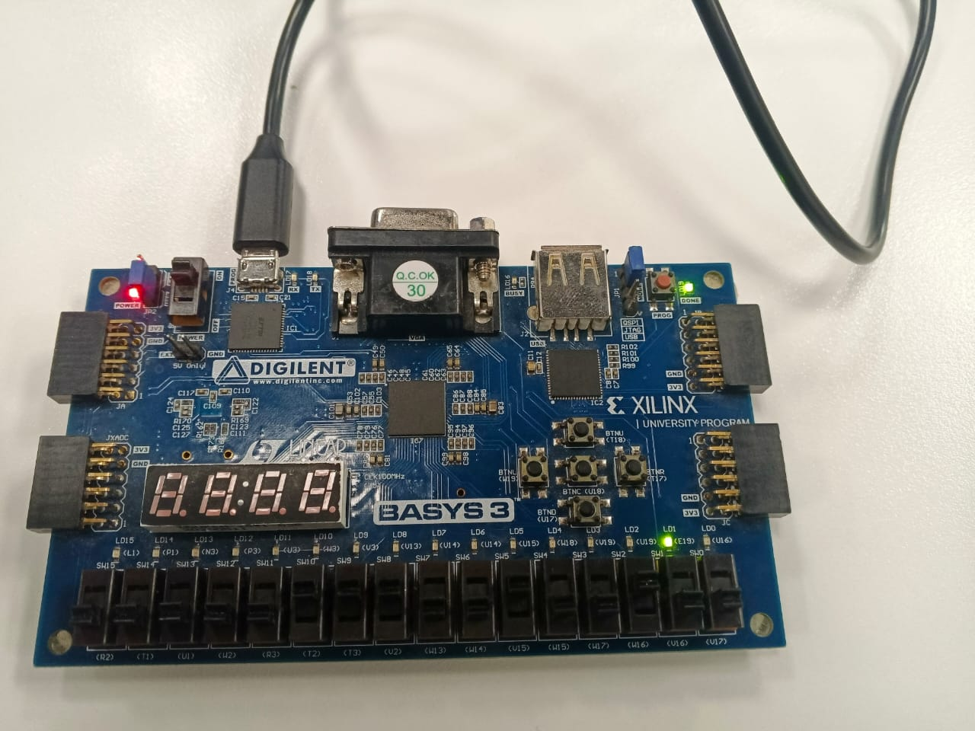

A= 1 , B = 2

ALU control = 0001 (SUB):
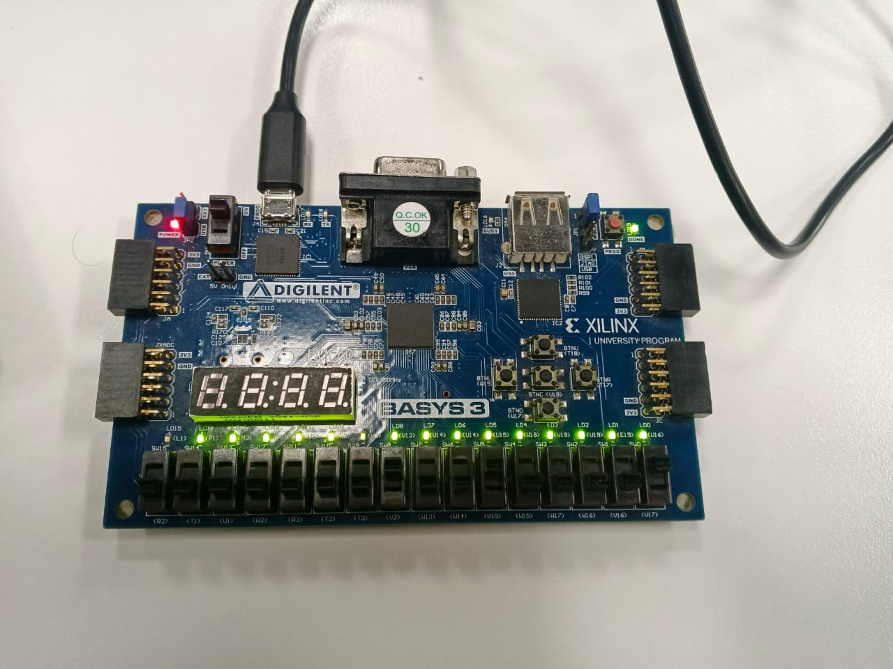
LED output = -1 (Sign extended)

Jazib github repo link :
https://github.com/jazibjaved0106/Labs-mj11972/tree/main/CA_Lab_06

https://github.com/Ahmaddddd7/CA_LAB/tree/main/lab6

Lab 05 – Designing FSM Using FPGA Switches and LEDs

Assessment Rubrics

Points Distribution
Task No. | LR2  Code | LR 5  Results | LR11  Design | AR7
Task 1 | - | - | /20 | /20
Task 2 | /20 | /15 |  | /20
Task 3 | /10 | /15 |  | /20
Total Points | /80 |  |  | /20
CLO Mapped | CLO 1
For description of different levels of the mapped rubrics, please refer the provided Lab Evaluation Assessment Rubrics and Affective Domain Assessment Rubrics.
# | Assessment Elements | Level 1: Unsatisfactory  Points 0-1 | Level 2: Developing  Points 2 | Level 3:Good  Points 3 | Level 4:Exemplary  Points 4
LR2 | Program/Code/ Simulation Model/ Network Model | Program/code/simulation model/network model does not implement the required functionality and has several errors. The student is not able to utilize even the basic tools of the software. | Program/code/simulation model/network model has some errors and does not produce completely accurate results. Student has limited command on the basic tools of the software. | Program/code/simulation model/network model gives correct output but not efficiently implemented or implemented by computationally complex routine. | Program/code/simulation /network model is efficiently implemented and gives correct output. Student has full command on the basic tools of the software.
LR5 | Results & Plots | Figures/ graphs / tables are not developed or are poorly constructed with erroneous results. Titles, captions, units are not mentioned. Data is presented in an obscure manner. | Figures, graphs and tables are drawn but contain errors. Titles, captions, units are not accurate. Data presentation is not too clear. | All figures, graphs, tables are correctly drawn but contain minor errors or some of the details are missing. | Figures / graphs / tables are correctly drawn and appropriate titles/captions and proper units are mentioned. Data presentation is systematic.
AR9 | Report | All the in-lab tasks are not included in report and / or the report is submitted too late. | Most of the tasks are included in report but are not well explained. All the necessary figures / plots are not included. Report is submitted after due date. | Good summary of most the in-lab tasks is included in report. The work is supported by figures and plots with explanations. The report is submitted timely. | Detailed summary of the in-lab tasks is provided. All tasks are included and explained well. Data is presented clearly including all the necessary figures, plots and tables.

